Project Report: COVID 19 Response
Yuva Rural Association

Organization details
Name of the Organization |  | Yuva Rural Association (YRA)
Vision and mission |  | Vision:“An empowered and capable society with all human rights; quality, peace, justice and security; without and discrimination on the basis of caste, creed, ethnicity, religion, gender, age and language; leading towards sustainability”.  Mission:“YRA is committed to facilitate social transformation through the socio economic, empowerment of the rural poor by establishing their access over rights and resources that will promote social equity, ecological balance and enable them to participate in good and responsive governance through their organizations and institutions”.
Brief about the NGO programmes |  | Yuva Rural Association (YRA) is registered in the year 2002 as a Society, and continues to toil hard for the development of the rural & tribal poor. The Organizational focus is to empower the deprived sections of rural and tribal society through interventions in the areas of livelihoods, gender, natural resource management (Environment) and advocacy to achieve its goals for the betterment of the constituencies. YRA’s current direct interventions are in more than 525 villages from around 18 blocks of eight districts in Vidarbha region and one district in Marathwada region of Maharashtra. All these interventions are to address various development issues of the constituency groups- small and marginal farmers, women, youth, tribal and children. YRA also have indirect interventions on various issues at state and national level through our collaborative partners. YRA has been successful in facilitating people’s Organizations and Institutions, thus increasing the participation, accountability, transparency, and ownership of our constituencies so that the social transformation process rolls on its own on sustainable mode. YRA has been successfully implementing diversion based irrigation project in Ramtek taluka of Nagpur district. Water & Sanitation program is being implemented in Washim district. Community Forest Rights and capacity building of local committee is being done through Government funding support, Sustainable agriculture and organic certification program is being implemented with 500 select farmers. Solar energy is being promoted in various projects, Small ruminants based livelihood is the model developed by YRA. Convergence of Government schemes for livelihood of poor households was successfully implemented under CAIM project in two clusters viz. Devli (Wardha district) and BarshiTakali (Akola district). YRA is part of many national level campaigns such as Wada Na TodoAbhiyan, VANI, ASHA, RRAN and also some state level networks such as Anemia Free Vidarbha Campaign, Vidarbha Livelihood Forum, Maharashtra Voluntary Action Network etc. YRA is a professional voluntary development organization working in partnership with International Development Organizations, National and State Government as also Corporate partners towards Sustainable Development. YRA is actively involved in national and international development processes such as Millennium Development Goals and now Sustainable Development Goals etc. It has young qualified, experiencedprofessionals for successful implementation of all program activities for social transformation in the areas where the Organization has involved since last many years.
Project details
Project Name |  |  | COVID 19 Response- EdelGive –YRA
Project Brief/background |  |  | The number of Covid-19 cases continued to surge in Vidarbha. The new cases are a major cause of worry as they feel it could be an indication of community spread of the corona virus.  Staying locked at homes and working from home is a privilege for a select few. A larger section of people who depend on Agriculture & non-agriculture, daily wage for their two square meal, losing the job, losing the pay, staying at home would not earn them the meal; there are many living with hunger in SDG era, additionally, the restrictions imposed on routine activities as part of social distancing to prevent the spread of disease, scores of migrant workers tend to move back to their native places. These are the most marginalized sections of the society who are dependent on daily wages for their living, and in times of such distress need sympathy and understanding of the society. Immediate concerns faced by such groups relates to food, children healthcare, agricultural activities & allied livelihood, fear of getting infected or spreading the infection, migrants coming back in village, concerns about the family, anxiety etc.  These people needed greater support because their livelihoods was likely to be hit the hardest. Sensitization, dry food, health and nutrition, agriculture and allied livelihood support, etc was to be made available to a much larger section of such people, including destitute, landless, small and marginal farmers, homeless and migrants through multiple mechanisms.  YRA has initiated the process to map and identify such needy families at various slums, roadside people, railway station, bus stand, huts where construction laborers reside throughout the city & few parts of Rural Vidarbha in Maharashtra state. Necessary arrangements have been made to seek inputs from the people to understand the potential beneficiaries, we realized that most people cannot afford to stay away from work and/or do not have the luxury of living conditions which allow “social distancing.” It is the livelihoods of these people that would be further affected as more and more work from home and/or reduce their economic activity.  Yuva Rural Association is working with the funding support of EdelGive for COVID 19 Response in 5 districts, i.e. Akola, Amravati, Bhandara, Nagpur, and Washim. The main interventions of the project are; baseline survey of 95 villages, showing impact of COVID 19 on livelihoods, and economic rejuvenation activities in these villages.
Project objective |  |  | - Mapping ultra-poor, daily wage workers, migrants and potential youth/ women for alternate livelihood opportunities.  - To aware, educate and mobilize all communities around Corona, Covid 19, spread, care to be taken etc. and behavior change.  To provide education and do individual counseling of identified people if necessary.  Identify new avenues of local livelihood options for next phase interventions.  - To assess the impact of COVID 19 on economic situation  - To rejuvenate the livelihood of small entrepreneurs at village level
Timeframe reported for |  |  | October 2020 to March 2021
Geographic Outreach |  |  | 95 villages from the districts of Akola, Amravati, Bhandara, Nagpur, and Washim of Vidarbha region of Maharashtra State.
Beneficiary group(s) |  |  | Small entrepreneurs, Women headed households, Small & Marginal Farmers, Youth group, SHG, BPL Goatery and Poultry owners
Fund sanctioned |  |  | Rs 23,00,408/- Funds received – Rs 23,00,408 /-
Fund utilized |  |  | Rs 23,00,408 /-
Project methodology
Key activities | - Livelihood Survey :  Baseline survey was developed to assess the socio-economic conditions of a village, and the impact of COVID 19. This survey was conducted in 95 villages in 5 districts. The data collected through baseline survey that included demographic information, Land holding, geographical information, sources of irrigation, crop pattern, ground water statistics, availability of Agriculture machinery in village, existing soil and water conservation practices, social concerns, economic situation, agriculture practices , energy, livestock, livelihood options, resource mapping etc. to find out the present conditions of the village. This data was analyzed, in order develop recommendations to combat the effect of COVID 19 in these villages. Report was prepared, and an action plan for these 95 villages was developed on the basis of this report. Through this we very well understood the overall condition of the SMF and vulnerable communities and also the benefits of Government schemes availed. We also understood the socio-economic and political trends in the villages. This report guided us in the further interventions in each village. Various existing groups at village level such as need of livelihood activity including farm and non-farm, migration status, SHG, youth groups, farmers groups, PRI members, opinion leaders, village level government functionaries etc. were engaged in this exercise.  - Assistance Rejuvenation of Small Entrepreneurs at village level :  While doing our baseline and RRA, it has been found that some of the existing small entrepreneurs like Potters, Carpenters, Cobblers, Ironsmiths, Barbers and Broom makers have lost their business during this pandemic situation and in need of restart their business which is the only source of their livelihood. These entrepreneurs are not able to avail loan facility from any of the banks as they do not have that much credibility. So through this intervention we provided the selected beneficiaries the required raw material and equipment of worth Rs.10,000/each which was given as Interest Free Loan. After 8-10 months of duration this loan will be recovered as Revolving Fund depending upon their business and income patterns. We will recover this amount in an easy installments, thereafter will be deposited in Revolving Fund specially created under this project. This fund will be used for another lot of needy entrepreneurs. This way it will create ownership and accountability among the beneficiaries. One beneficiary from each profession was selected from each district (total 6 beneficiaries per district, in 5 districts). These total 30 beneficiaries were given equipment worth Rs. 10, 000 each as an interest free loan. Guarantees were obtained from sarpanch and one other prominent individual.  - Livelihood Support to Single women / Mother headed family:  10 needy single women who were heads of households were provided an interest-free loan of Rs 15,000 each in the form of equipment and supplies to set up a small kirana shop (grocery store). Repayments from this loan will also form a revolving fund to help other needy women in the future. This way it also created ownership and accountability among the beneficiaries. We proposed 10 such beneficiaries, two from 5 districts of project area.  - Establishment of Kitchen Gardens:  In the project area villages where women and children are more vulnerable towards falling anemic and malnourished where affordability of good source of food is also a challenging reality. In order to address this issue one more activity was introduced as backyard kitchen gardens among the vulnerable HHs. 1000 such units were supported and promoted under the project. The project staff ensured that each of the family develops such kitchen garden as regular practice. 1000 households were given support for setting up kitchen gardens, including seeds, and information / training. Beneficiaries were selected on the basis of willingness to set up the kitchen garden, and availability of suitable land and water.  - Goatery Support (including transport) :  The project area is mainly based on rain fed farming. SMF & landless families in rain fed area get engage in activities like Goatary & Poultry as backup support. But they do not look at this as business activity. So they do not pay much attention towards this activity and so loose animals every year worth Rs. 15000 to 20000. YRA has developed a successful model of taking three major care of goats i.e. preventive health measures, proper shelter and their minimum nutritional needs. Training to the Para-veterinary is also done under this project who will help farmers in Vaccination, Goat Shed Management & Nutrition. If these three aspects are brought in practice a family can get minimum Rs.15, 000 as additional family income every year. So the support was provided to the selected 100 poor hh by giving one goat to those who are having 2-3 goats with technical support as agri-allied activity. Training would be provided of taking three major care of goats i.e. preventive health measures, proper shelter and their minimum nutritional needs. Beneficiary selection for this activity has been done.  The weight of one goat is around 21-23 kg. In one year one goat will produce 1 child and gain weight of around 30-33 Kg. In the meat market, wholesale rate of goat is approx. 400 rs per kg. So if the family will sell 2 goats each year in the market @ 400 rs per Kg it will get approx. 25000 Rs per year. If we exclude maintenance cost which is around 8000 rs per goat ( food- 3000, vaccination & medicines -3000, maintenance -4000) farmer will get up to approx. 15000 rs per year annually as net profit. The income against no loss here is not included. It is expected that the project staff will encourage another group of 100 families towards this IGA during the project period.  - Poultry Support:  100 selected hhs from Women headed, Marginal farmer and landless have been supported for poultry units with size of 7 chicks as agro allied activity. Same as goat rearing this activity was also not seen as business activity by the farmers. The cost of one unit of 7 birds is approx. 700/- (@100/- per chick). Even if we consider 20% mortality rate, in 45 days 6 chick will grow and become ready for selling. The average selling rate for desi chicken is approx. 400 rs per kg. Even if we exclude maintenance cost which of around 200 rs per bird ( food & nutrition- 100, vaccination & medicines -50 shelter & maintenance -50) women will get up to approx. 4000 rs in every 45 days after selling of 5 birds (considering average weight of 2kg per bird). As effect five time sale of birds will bring approx. 20,000 rs as income per year.  - Veterinary Support through the Training of Barefoot Para-veterinaries:  Since the project has been promoting small ruminant based income generating activities, there has to be back-up veterinary support for the vaccination, minimum nutrition and proper shelter for both goats and poultry. Existing government services are not very useful. YRA proposed to train interested 5 youth (male & female) in each district as para-veterinary and provided training to 5 Para veterinary service providers from the needy families, who were selected from the project villages and who will extend their services in their own and surrounded villages. Training and demonstration was provided on vaccination, minimum nutrition and proper shelter for both goats and poultry.  These paravets will provide these services and guidance and earn out of that. At one level the goat rearing hh will save around 15000 every year because of these veterinary care and these para veterinaries will earn money from the services they provide. The veterinary expert will be available on call for expert inputs for these para-veterinaries. After project end these services will be given by Para veterinaries continuously.  - Agriculture Equipment to Youth Farmer Group :  Soya bean and Tur is a major crop taken by farmers in Rabi season. We had proposed and provided Razor equipment for cutting the crops during harvesting season to one selected youth farmers group. Razor & ploughing attachment- On an average in one season ( considering of 30 days) will run on rent for 2000 Rs/ acre & will cover 300 acre in whole season gives the earning 2000*25= 50,000 Rs in one season. If we exclude expense of Rs. 7500/- operating charges of driver (@ 300 Rs per acre) then in one season will give net profit of 42,500 Rs. to farmers group. The cost of this equipment is Rs. 50,000 ,out which we have provided Rs. 30,000 and the rest Rs. 20,000 is the farmer's contribution  - Custom Hiring Center (Tool Bank) through Women SHG:  In order to create easy access to the farm implements and machinery, it was proposed to start 1 such custom hiring center through the existing SHG and accordingly it has been provided to one selected SHG from Karanja-lad block of Washim district. The SHG will provide the implements on hire to all SMFs in the surrounding project villages by which drudgery of SMFs will reduce and in time cultivation of crops will be possible. Appropriate women SHG was identified. The group will be trained in managing the center. The SHG group will be monitored and hand holded even after the project duration. They will be submitting their monthly business report regularly to the organization. After the one year period of their business, they will be contributing 1 % of their profit for the maintenance of assets and will be accumulated in Maintenance fund which will be created especially for this purpose.  - Awareness Programs on Issues Related to COVID 19:  1 Awareness program was conducted in all 95 villages of 5 Districts on Concept , precautions, treatment and overall Impacts of COVID 19. The existing IEC material was used and disseminated among the community people.
Key challenges faced | - Lockdown delayed the process of delivering goats, and the procurement and delivery of agricultural equipment to women SHG and youth farmer group
The impact created from the intervention
Project outcome achieved as against the target set | Activity
 |  |  |  | Tasks planned | Tasks achieved | Outcome achieved
 |  |  |  |  |  | Quantitative | Qualitative
 | Baseline to identify ultra-poor daily wage families, migrant people and potential youth/ women around their livelihood |  |  | - Designing & Printing of questionnaire.  - Conducting survey and data entry  - Analysis & Reporting | - Baseline Survey was done in 95 villages  - Data analysis was done  - Report on survey results, as well as recommendations based on the results, was prepared and submitted. | - 95 villages covered.  - District level analysis prepared for 5 districts | - Understanding developed of socio-economic status of 95 villages  - This understanding formed basis of recommendations to combat effect of COVID 19 on vulnerable households
 | Rejuvenation of Small Entrepreneurs at village level |  |  | - Beneficiary identification  - Develop list of equipment to be supplied  - Repayment agreement | - 6 beneficiaries ( 1 potter, carpenter, cobbler, ironsmith, barber, and broom maker) from each 5 districts (total 30 beneficiaries)  - Ordering of equipment of Rs 10,000 each on basis of needs of each profession  - Signing of loan repayment agreement  - Disbursement of equipment | - 30 beneficiaries received equipment (materials and tools) to rejuvenate their business | - Opportunity for these beneficiaries whose businesses had suffered because of the COVID 19 pandemic
 | Establishment of home-based kirana shops for women headed families |  |  | - Identification of needy women  - Develop list of equipment to be supplied  - Repayment agreement | - 10 beneficiaries were identified  - Ordering of equipment of Rs 15,000 each (weighing machine and supplies including tea, pulses, oil, sugar, chips packets etc)  - Signing of loan repayment agreement  - Disbursement of equipment and supplies | - 10 beneficiaries received equipment and supplies to set up a home-based kirana shop | - Beneficiaries established a shop in their home which supported the household through income generation
 | Establishment of Kitchen garden |  |  | - Beneficiary selection process  - Establishing 100 kitchen gardens | - Stakeholder’s selection is done on the basis of willingness to set up the kitchen garden, and availability of suitable land and water.  - 100 kitchen gardens established. | - 100 women developed a kitchen garden.  - 7-8 vegetables such as Tomato, Brinjal, Snakebean, Ladyfinger are grown. | - Consciousness of a healthy diet among women.  - Free source of good quality nutrition  - Participation of women in the development of kitchen garden.
 | Goatery support |  |  | - Beneficiary selection process  - Procurement and delivery of goats | - 100 poor households who are already having 2-3 goats were identified | - Approx. Rs. 25,000 as income per year. | - Additional source of Income for needy household.
 | Poultry Support |  |  | - Beneficiary selection process  - Procurement and delivery of chicks | - 7 chicks were delivered to each of the 100 households | - Approx. Rs. 20,000 as income per year | - Additional source of income for needy households
 | Training of barefoot para-veterinaries |  |  | - Identify 5 candidates youths (male and female) for training from project villages based on interest  - Conduct training on vaccination, minimum nutrition and proper shelter for both goats and poultry | - 5 youth (male & female) in each district as para-veterinary and provided training to 5 Para veterinary service providers from the needy families. | - Gotery and Poultry HH earn Rs. 15000 per year. | - Goat rearing and Poultry hh will save around 15000 every year because of these veterinary care and these para veterinaries will earn money from the services they provide.
 | Agriculture equipment to youth farmer group |  |  | - Identify appropriate youth farmer group  - Collect contribution of Rs 20,000 from farmer group  - Procure razor and plough worth Rs 50,000 and arrange delivery to farmer group | - Provided Razor equipment for cutting the crops during harvesting season to one selected youth farmers group. | - Earn Rs. 50,000 in one season. | - Increase in income by lending equipments to other needy farmers.
 | Establish custom hiring center (tool bank) for women SHG |  |  | - Identify appropriate women SHG  - Provide training to group on business, accounting, and banking activities  - Collect contribution of Rs 20,000 from SHG  - Procure razor and ploughing attachment and BFF machine and arrange delivery SHG  - Mentoring and monitoring of SHG | - 1 such custom hiring center provided to one selected SHG from Karanja-lad block of Washim district. | - Generate income around 20,000 per SHG member in a year | - They will be lending the equipments to needy farmers and genrrate the source of income.
 | Awareness Programs |  |  | - Conduct awareness programs on concept , precautions, treatment and overall impacts of COVID 19 | - Awareness programs were carried out in all 95 project villages  - IEC material used and disseminated in each village | - Residents of 95 villages have accurate and reliable information on issues surrounding COVID 19 | - Spread of misinformation on COVID 19 is reduced  - Residents are more likely to take safety precautions

Key Learnings
- Households in rural communities are more vulnerable to economic disruptions, and many families felt deep impact of the pandemic.
- Livelihood rejuvenation activities gave many small entrepreneurs the opportunity to restart their business.
- Women headed families greatly benefit from small businesses that they can run from their own homes.
- Goatery and poultry rearing are a good agri-allied business, if information and support on care of the animals is given.
- Awareness programs on COVID 19 stop the spread of misinformation, and help in the reduction of spread by the use of suitable safety precautions.

CASE STORY #1: Vijay Kharade – Village Kupati

Kupati is located in Karanja taluka of Washim district, and has a population of 1400 from 450 families
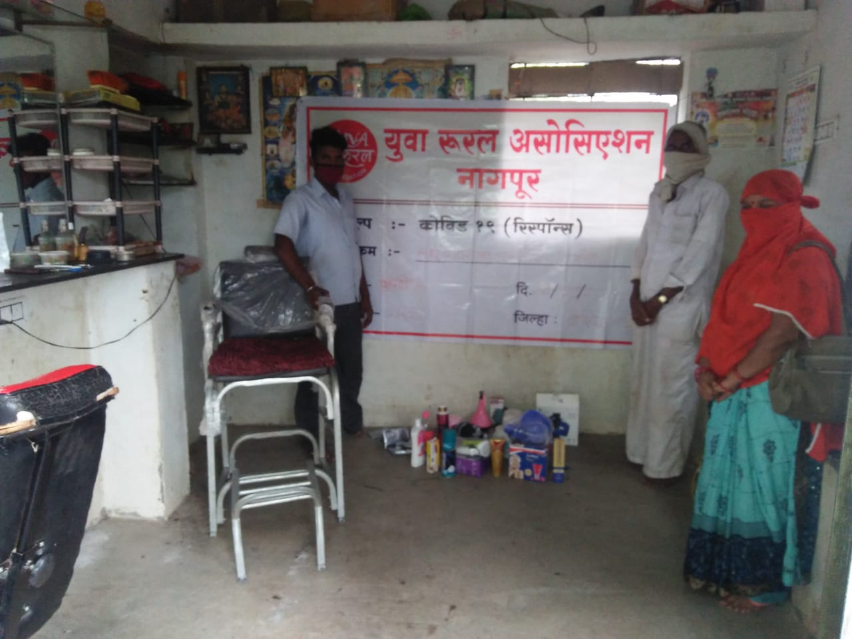
Vijay Kharadkar, a villager from Kupati, was selected as a beneficiary for small business rejuvenation. His leg is crippled from birth. He cannot walk or lift heavy objects.
He is lives with his elderly mother, father, wife and 2 daughters. In COVID 19, his young daughter underwent heart surgery. He borrowed money from a self-help group for the operation. His barber’s business has been running in Kupti for the last 5 years. COVID 19 has affected his business. He is earning alone in the family and cannot do any other work due to his disability. Therefore, he was selected as a beneficiary.
A loan repayment agreement, with the date, name of the organization, name of the person visited, name of the beneficiary, name of the village, age, name of the business, consent of the Sarpanch and Gram Panchayat were prepared. Thereafter, YRA provided him with supplies he needs to run his business.
The family was in dire straits, but the organization's financial support helped them meet their family's financial needs, and helped to educate girls and raise their standard of living.

CASE STORY #2: Shamin Bano Sheikh Ayub – Village Pimpalgaon

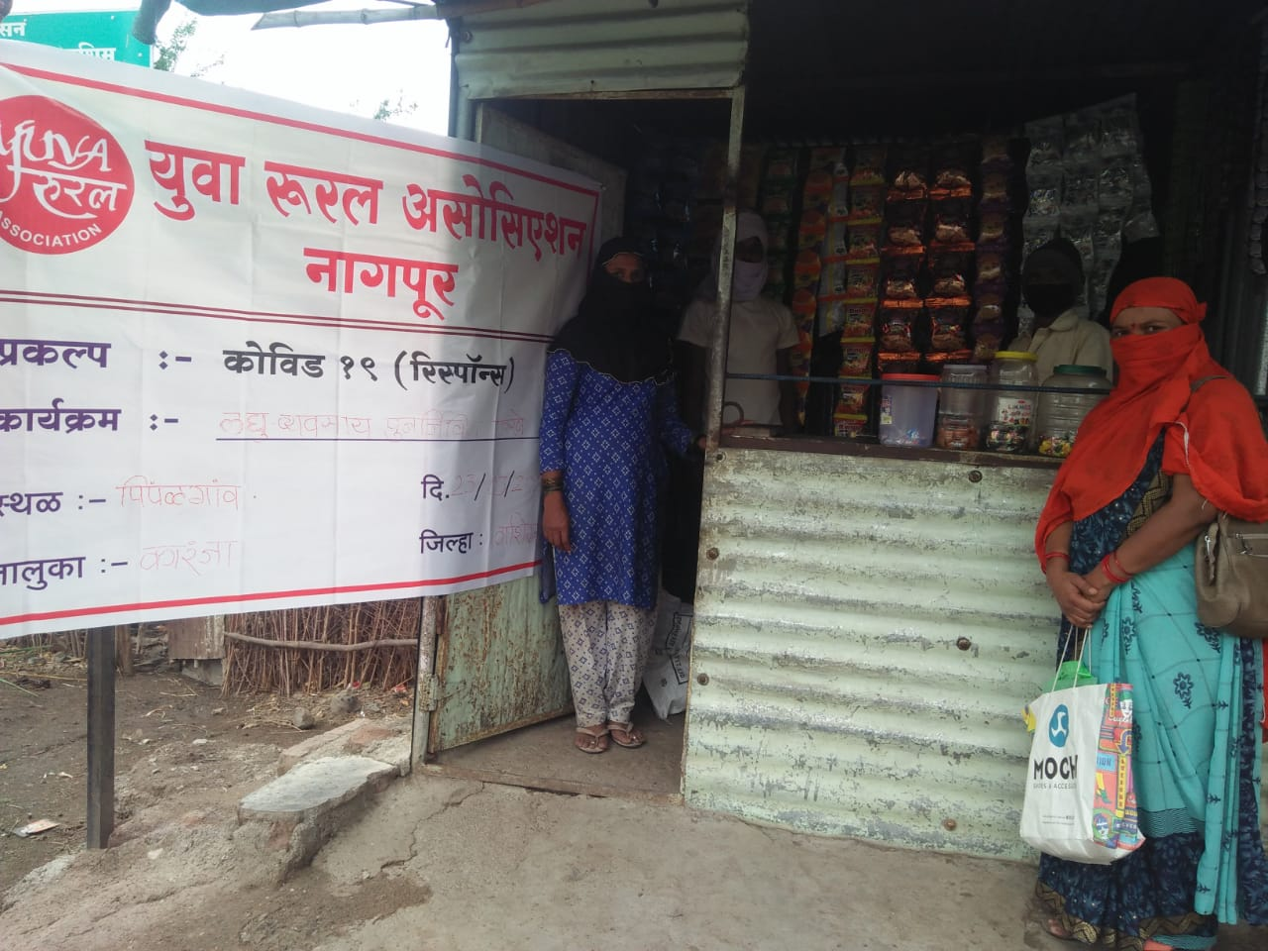
Shamin Bano lives in Pimpalgaon, in Karanja Taluka, with her husband and two children. Her husband is disabled, and can't work, so she runs a small grocery store in the village to support the family. The children are in school, so their education and daily necessities are all covered by running the grocery store. Due to lack of money, her shop is operating on an extremely small scale. She tried to take a loan from a village level to make the shop bigger, but she did not get a loan without a lender's mortgage.
Shamin’s shop was in worse financial state after the COVID 19 crisis. However, she had both ability and perseverance, she just needed guidance and courage. If she was helped to grow her business, her family can become financially stable.
He visited them and realized that after Kovid 19 in the village, it would help them to raise their living standards and if they were given a little help to do so, instead of closing down these businesses, they would be encouraged to grow in rural areas. After that the agreement of the beneficiaries was prepared as follows
Shamin stocked her small shop with the help of a loan under this project. Under the loan agreement, she would not have to pay any interest. Not only did this help her to restart her business, she could also escape the high interest rates charged by the local lender. This has now put her, and hence her family, on the path to economic stability.

Village | Gram Panchayat | Administrative  Block | District
Akoli | Akoli | Murtijapur | Akola
Bidgaon | Bidgaon | Murtijapur | Akola
Borgaon | Borgaon | Murtijapur | Akola
Borta | Borta | Murtijapur | Akola
Datala | Datala | Murtijapur | Akola
Jitapur | Jitapur | Murtijapur | Akola
Khandala | Khandala | Murtijapur | Akola
Kinkhed | Kinkhed | Murtijapur | Akola
Malkapur | Nagoli | Murtijapur | Akola
Nagthana | Rambhapur | Murtijapur | Akola
Chinchkhed | Ramtek | Murtijapur | Akola
Salatwada | Salatwada | Murtijapur | Akola
Samsherpur | Samsherpur | Murtijapur | Akola
Sangwi | Sangwi | Murtijapur | Akola
Sirso | Sirso | Murtijapur | Akola
Lontek | Lontek | Amravati | Amravati
Malkapur | Malkapur | Amravati | Amravati
Gourkheda | Gourkheda | Bhatkuli | Amravati
Jasapur | Jasapur | Bhatkuli | Amravati
Khalkhoni | Khalkhoni | Bhatkuli | Amravati
NandedKhurd | NandedKhurd | Bhatkuli | Amravati
Rinmochan | NandedKhurd | Bhatkuli | Amravati
NimbhoraBaki | Parlam | Bhatkuli | Amravati
Parlam | Parlam | Bhatkuli | Amravati
Sayat | Sayat | Bhatkuli | Amravati
Adgaon | Adgaon | NandgaonKhandeshwar | Amravati
Januna | Januna | NandgaonKhandeshwar | Amravati
Khirsana | Khirsana | NandgaonKhandeshwar | Amravati
Nirsana | Khirsana | NandgaonKhandeshwar | Amravati
Timtala | Khirsana | NandgaonKhandeshwar | Amravati
Bachera | Bachera | Mohadi | Bhandara
Futara | Bachera | Mohadi | Bhandara
Bondri | Bondri | Mohadi | Bhandara
Ghorpad | Bondri | Mohadi | Bhandara
Chicholi | Chicholi | Mohadi | Bhandara
Dhop | Dhop | Mohadi | Bhandara
Dhusala | Dhusala | Mohadi | Bhandara
Hardoli | Hardoli | Mohadi | Bhandara
Hivra | Hivra | Mohadi | Bhandara
Jamb | Jamb | Mohadi | Bhandara
Kandri | Kandri | Mohadi | Bhandara
Kati | Kati | Mohadi | Bhandara
Khairlanji | Khairlanji | Mohadi | Bhandara
Khamari / Buj | Khamari / Buj | Mohadi | Bhandara
KhutSawari | KhutSawari | Mohadi | Bhandara
Neri | Neri | Mohadi | Bhandara
Pachgaon | Pachgaon | Mohadi | Bhandara
Pandharabodi | Pandharabodi | Mohadi | Bhandara
Chorkhamari | Pimpalgaon | Mohadi | Bhandara
Pimpalgaon | Pimpalgaon | Mohadi | Bhandara
Mandesar | Rampur | Mohadi | Bhandara
Sitepar (Z) | Sitepar (Z) | Mohadi | Bhandara
Siwani | Siwani | Mohadi | Bhandara
Asoli | Asoli | Ramtek | Nagpur
Bandra | Bandra | Ramtek | Nagpur
Bhandarbodi | Bhandarbodi | Ramtek | Nagpur
Hasapur | Bhandarbodi | Ramtek | Nagpur
Salaimeta | Bhandarbodi | Ramtek | Nagpur
Borda | Borda | Ramtek | Nagpur
Sarakha | Borda | Ramtek | Nagpur
Ghoti (Dahoda) | Dahoda | Ramtek | Nagpur
Jamuniya | Dahoda | Ramtek | Nagpur
Akola | Khanora | Ramtek | Nagpur
Khanora | Khanora | Ramtek | Nagpur
Mahadula | Mahadula | Ramtek | Nagpur
Mandri | Mandri | Ramtek | Nagpur
Murda | Mandri | Ramtek | Nagpur
Guguldoh | Panchala | Ramtek | Nagpur
Panchala (Bu) | Panchala | Ramtek | Nagpur
Ambazari | Patharai | Ramtek | Nagpur
Ghoti (Ramjam) | Salai | Ramtek | Nagpur
Kirnapur | Shivani | Ramtek | Nagpur
Shivani | Shivani | Ramtek | Nagpur
Manegaon (Kala) | Warghat | Ramtek | Nagpur
Saundani | Warghat | Ramtek | Nagpur
Babapur | Babapur | Karanja | Washim
Bambarda | Bambarda | Karanja | Washim
Belkhed | Belkhed | Karanja | Washim
Kamatha | Belkhed | Karanja | Washim
Shemlai | Belkhed | Karanja | Washim
Bhamdevi | Bhamdevi | Karanja | Washim
Bhiwari | Bhiwari | Karanja | Washim
Bhuloda | Bhuloda | Karanja | Washim
Brahmanwada | Brahmanwada | Karanja | Washim
Dhotra | Dhotra | Karanja | Washim
Dongargaon | Dongargaon | Karanja | Washim
Hiwaralahe | Hiwaralahe | Karanja | Washim
Kupati | Kupati | Karanja | Washim
Ladegaon | Ladegaon | Karanja | Washim
Malegaon | Malegaon | Karanja | Washim
Kurhad | Mashalalodi | Karanja | Washim
Pimpalgaon | Pimpalgaon | Karanja | Washim
Pimpri | Pimpri | Karanja | Washim
Shirsoli | Shirsoli | Karanja | Washim
Vilegaon | Vilegaon | Karanja | Washim

